Lec 4 Designing Landing Page Part 4

* 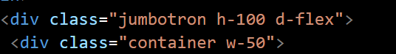
* h-100:This means set height 100%
* W-50:width 50%
* Jumbotron is already existing class in the source code
* d-flex:display flex
* 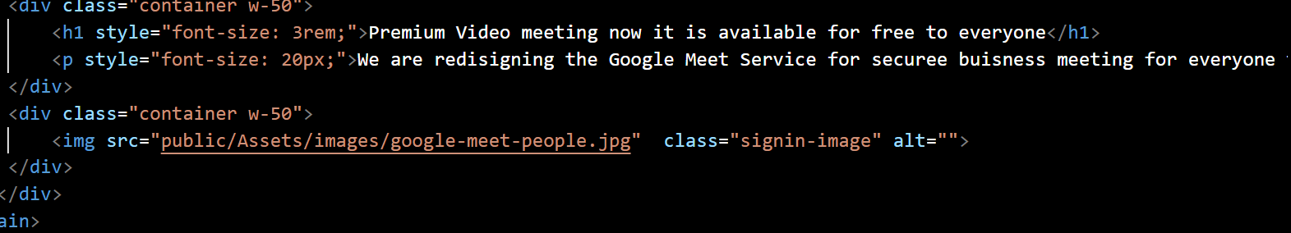
* Applying css to the image
* 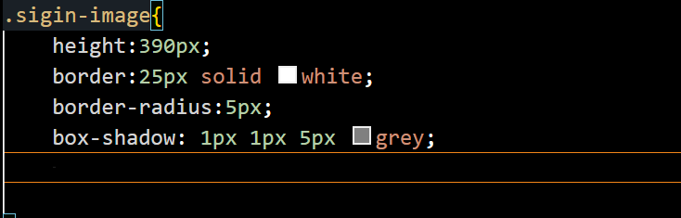
* Box-shadow is useful to give a shadow effect
* Now here we will be creating buttons
* 



* Now to add icons of the particular info int the button itself
* 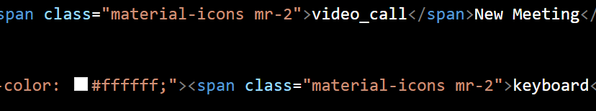
* To remove outline of the text area of the button
* 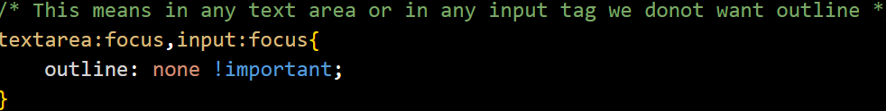
* 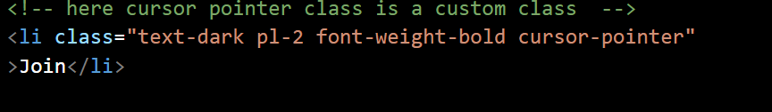
* Now we will make a class cursor pointer hence the text on which the cursor should become pointer that is written in the same class
* 
* 
 